Database | MEDLINE (Ovid), EMBASE (Ovid), PubMed
Date of Search | April 30th 2026
Search Combination | Population AND Intervention
Line | Search Terms
1 | exp Vancomycin/
2 | vanco*.tw,kf.
3 | 1 or 2
4 | exp Arthroplasty, Replacement, Knee/
5 | (TKA or TKR).tw,kf.
6 | (knee adj3 (arthroplast* or replac*)).tw,kf.
7 | 4 or 5 or 6
8 | 3 and 7
9 | hip.tw,kf.
10 | 8 not 9
Supplementary table 1: Database search strategy.

Author, Year | Country | Design | Intervention | Data Period | Follow-up Duration | NOS | ROBINS-I | RoB-2
Abuzaiter et al. 2023 | Canada | RCT | No vancomycin vs. Topical | Aug 2016 - Sept 2017 | 42 days | N/A | N/A | Some concerns
Aflatooni et al. 2026 | USA | Retrospective chart review | IO vs. IV | Jul 2016 - Nov 2024 | 2 days | Low | Moderate | N/A
Aljuhani et al. 2021 | Saudi Arabia | Retrospective chart review | No vancomycin vs. Topical | Jan 2018 - Mar 2020 | 3 months | Moderate | Serious | N/A
Chin et al. 2018 | New Zealand | RCT | IO vs. IV | May 2015 - May 2016 | 6 months | N/A | N/A | Low
Doxey et al. 2024 | USA | Prospective quality control | No vancomycin vs. Topical | Oct 2021 - Sept 2022 | 90 days | Low | Moderate | N/A
Hanada et al. 2019 | Japan | Prospective | No vancomycin vs. Topical | 2010-2017 | 1 year | Low | Serious | N/A
Harper et al. 2020 | USA | Retrospective chart review | IO vs. IV | Sept 2018 - Mar 2019 | 90 days | Low | Moderate | N/A
Johnson et al. 2017 | USA | Prospective case series | No vancomycin vs. Topical | June 2014- sept 2014 | 1 day | N/A | N/A | N/A
Khatri et al. 2017 | India | Retrospective chart review | No vancomycin vs. Topical | Feb 2014 - Jan 2016 | 1 year | Moderate | Critical | N/A
Mulpur et al. 2024 | India | RCT | No vancomycin vs. Topical | Jan 2021 - Jan 2022 | 1 year | N/A | N/A | Low
Park et al. 2021 | USA | Retrospective chart review | IO vs. IV | May 2016 - Jul 2020 | 90 days | Low | Low | N/A
Park et al. 2025 | USA | Retrospective chart review | IO vs. IV | May 2016 - May 2023 | 90 days | Low | Moderate | N/A
Parkinson et al. 2021 | Australia | Retrospective chart review | No vancomycin vs. Topical | Jan 2013 - Dec 2017 | 5 years | Low | Low | N/A
Spangehl et al. 2022 | USA | RCT | IO vs IV | - | 1 day | N/A | N/A | Some concerns
Tahmasebi et al. 2021 | Iran | Retrospective chart review | No vancomycin vs. Topical | Mar 2007 - Dec 2018 | 1 year | Low | Serious | N/A
Wininger et al. 2024 | USA | RCT | IO vs. IV | Jan 2023 – Oct 2023 | 90 days | N/A | N/A | Some concerns
Xu et al. 2020 | China | Retrospective chart review | No vancomycin vs. Topical | May 2015 - Oct 2017 | 1.5 years | Low | Low | N/A
Yavuz et al. 2020 | Turkey | Retrospective chart review | No vancomycin vs. Topical | 2012-2016 | 2 years | Low | Serious | N/A
Supplementary table 2: Summary of study characteristics of included studies (n=18).
Supplementary figure 1: Forest plot of “leave-one-out” analysis for acute kidney injury rates at 30 days of included studies.
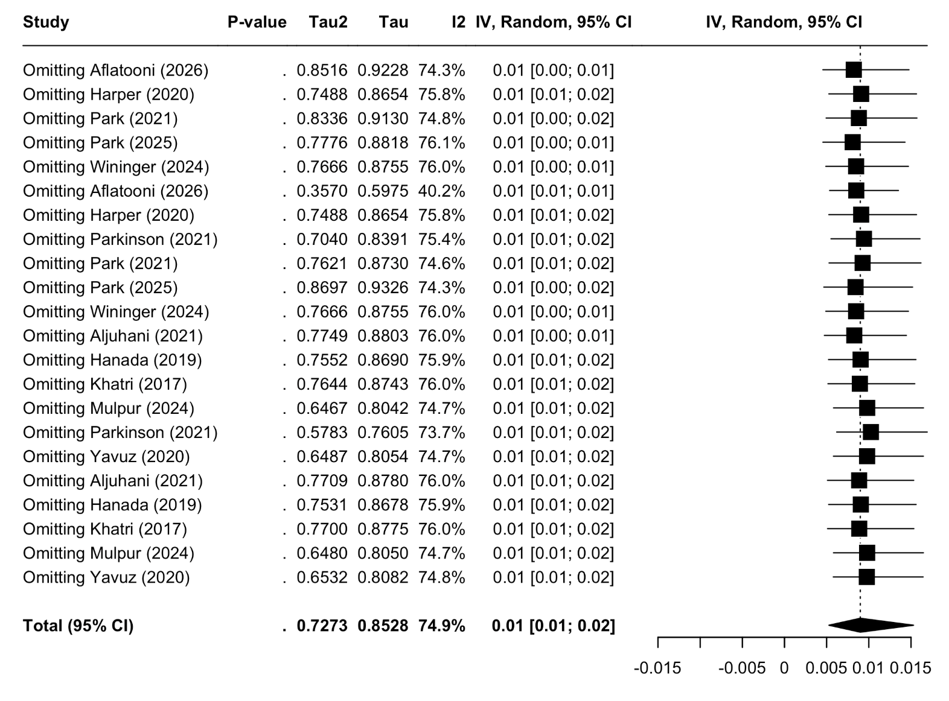

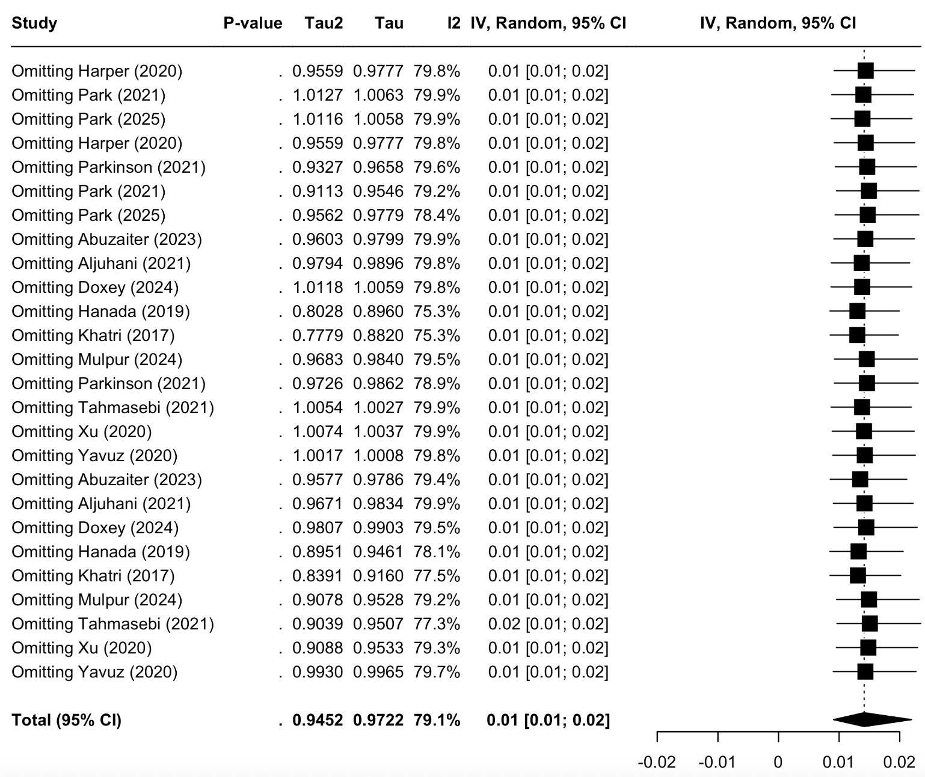
Supplementary figure 2: Forest plot of “leave-one-out” analysis for prosthetic joint infection rates at 90 days of included studies.

Supplementary figure 3: Forest plot of pooled and subgroup meta-analysis of 90-day reoperation rate .
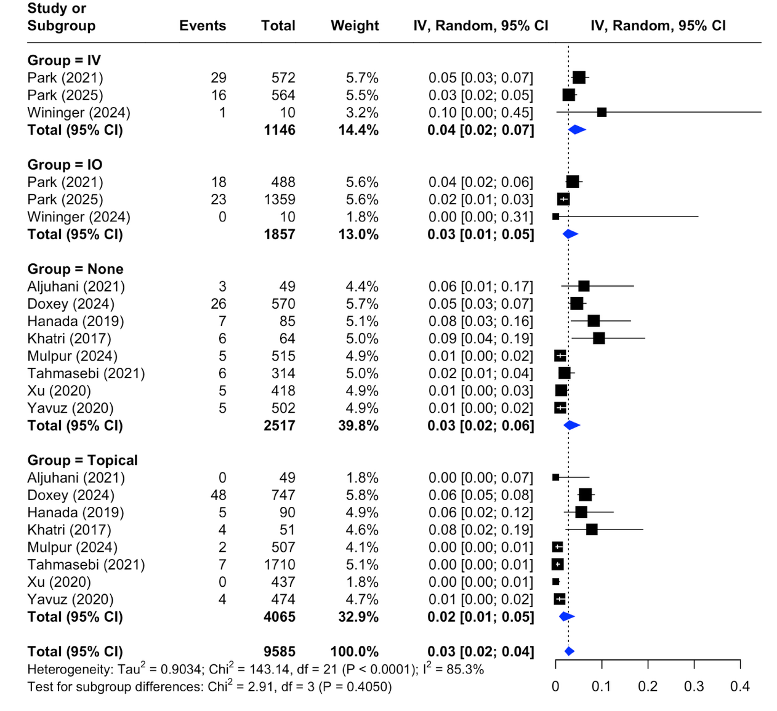

Supplementary figure 4: Forest plot of pooled and subgroup meta-analysis of 90-day superficial SSI rate.
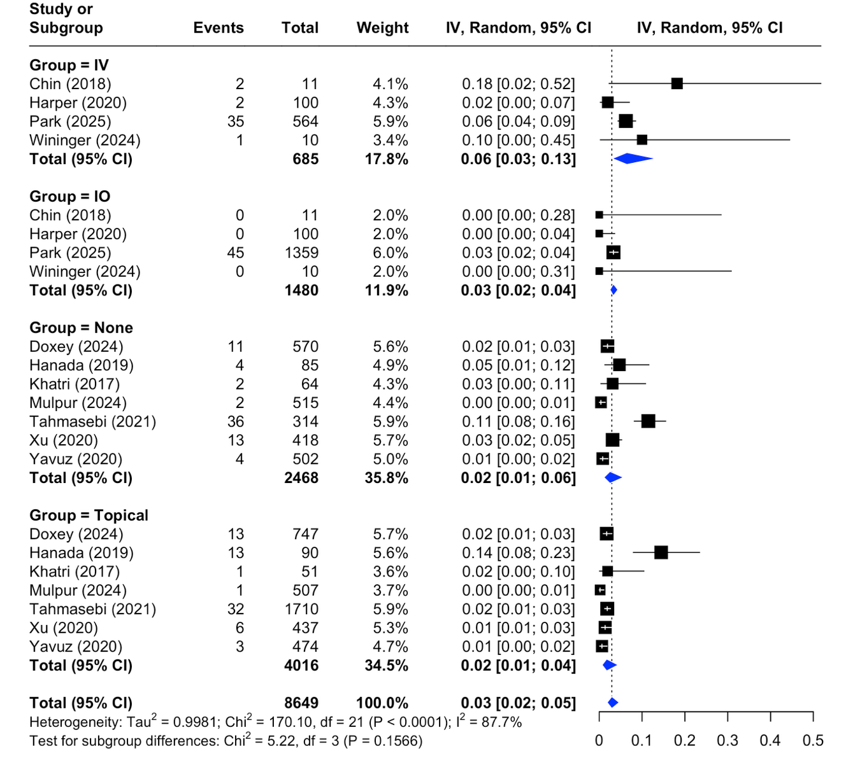

Supplementary figure 5: Forest plot of pooled and subgroup meta-analysis of 90-day venous thromboembolism rates.
